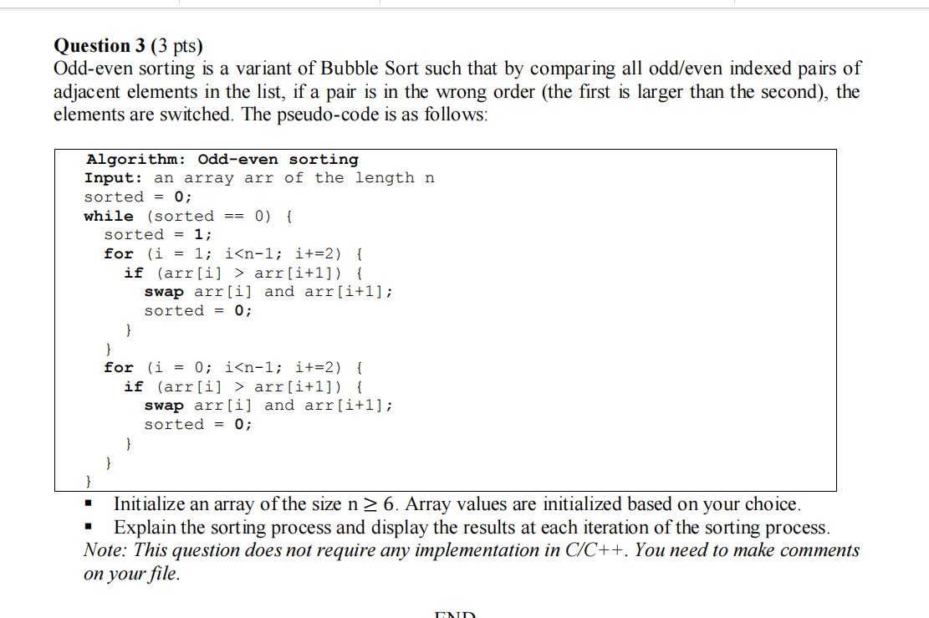
3 2 6 5 1 4
0 1 2 3 4 5
N = 6
I from 1 to 5 step 2 => 1, 3, 5
3 2 6 1 5 4
I from 2 to 6 steo 2 => 0, 2, 4
2 3 1 6 4 5
2 1 3 4 6 5
1 2 3 4 5 6

